**Structures Summary**

1. **What is a structure?**

* Structure is a user defined data types in C and this data type can be used to group items of different types into a single type.

1. **How to declare structure variables?**

* Can be declared with structure declaration or as a separate declaration.

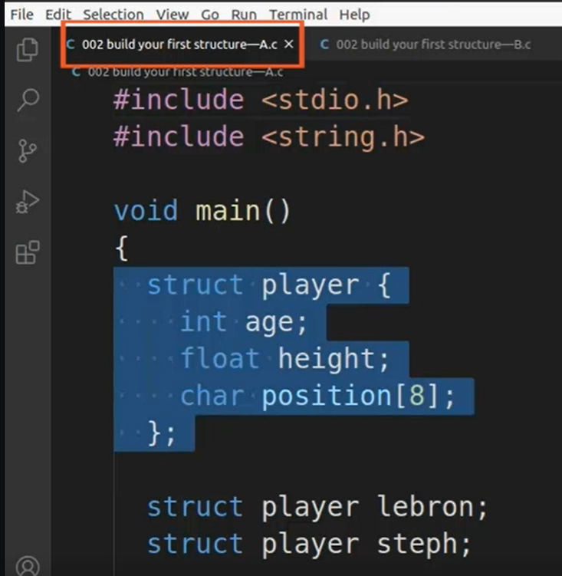 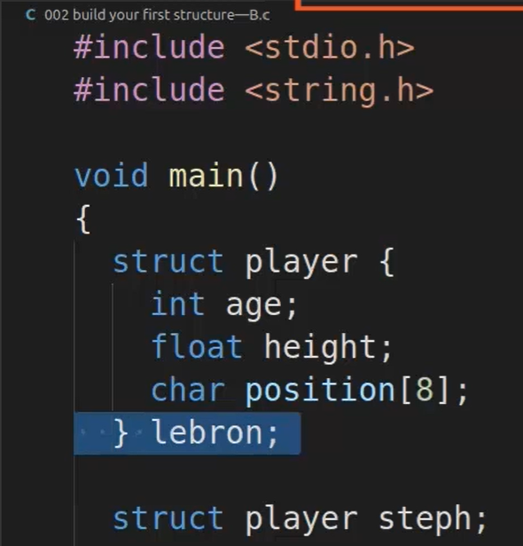

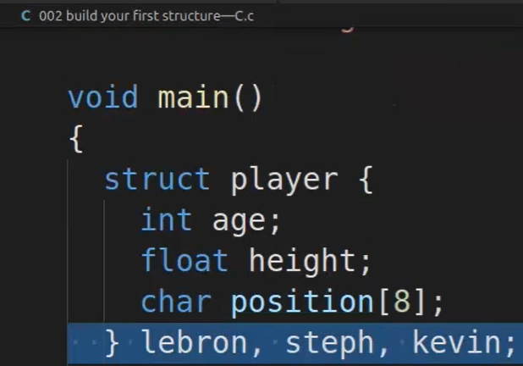

1. **How to access structure elements?**

* Using .(dot) operator

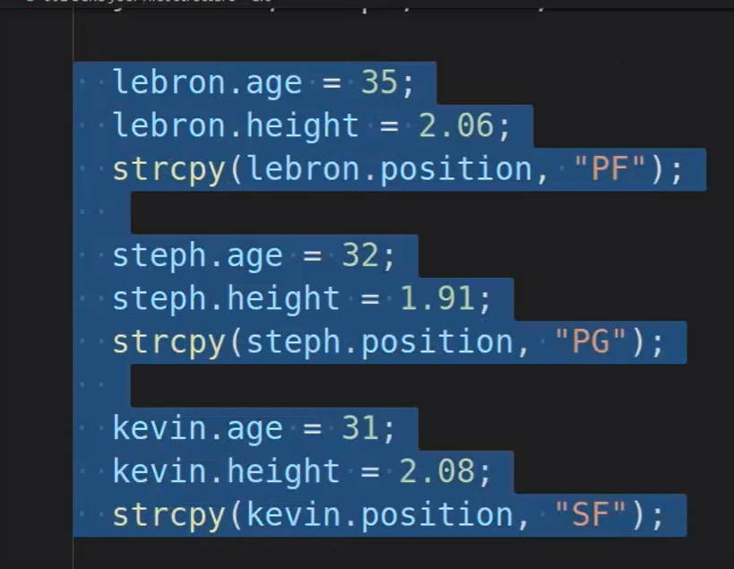

1. **Nested Structures –**

* Nested Structure is a structure within a structure.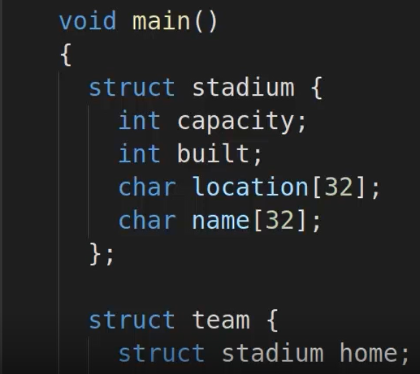
* Nesting a structure more than once.

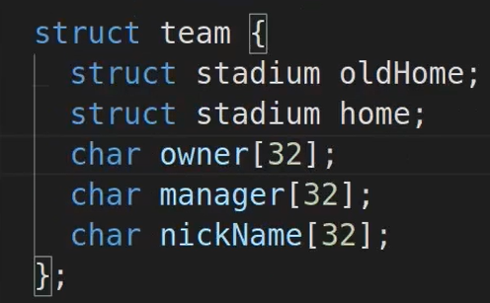

1. **What is an array of structures?**

* An array of structures in C can be defined as the collection of multiple structures variables where each variable contains information about different entities. And array of structures are used to store information about multiple entities of different data types.

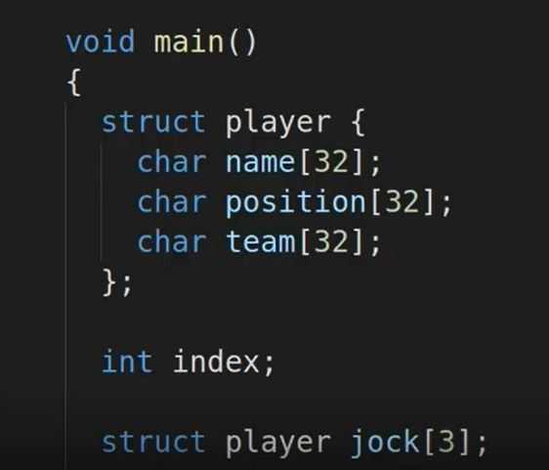

* Assigning values into array of structure.

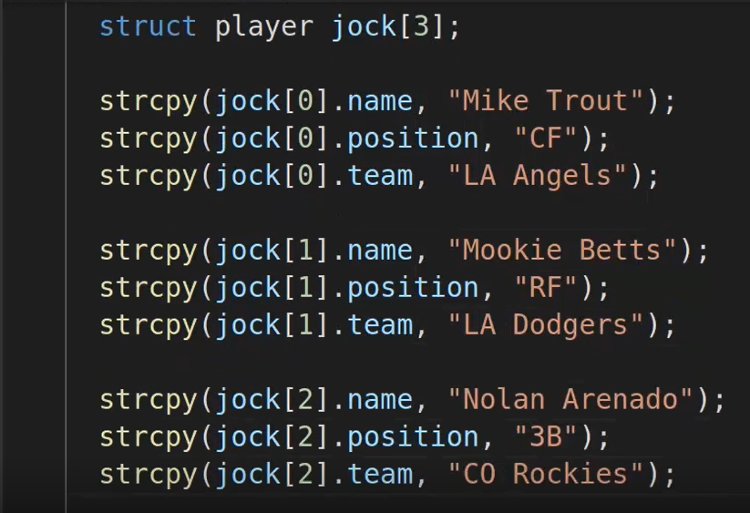

1. **What is a pointer?**

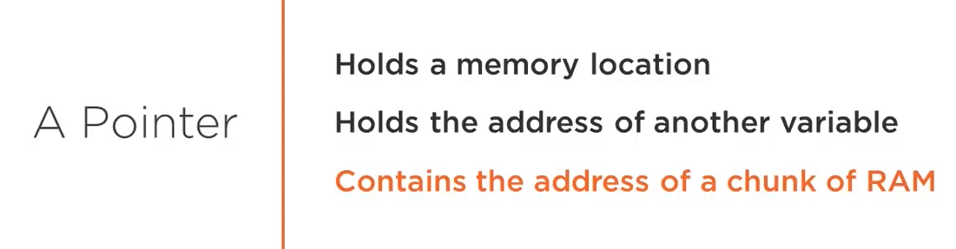

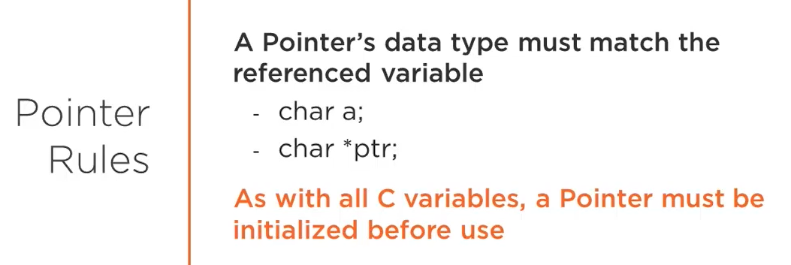

1. **Syntax of a pointer**.

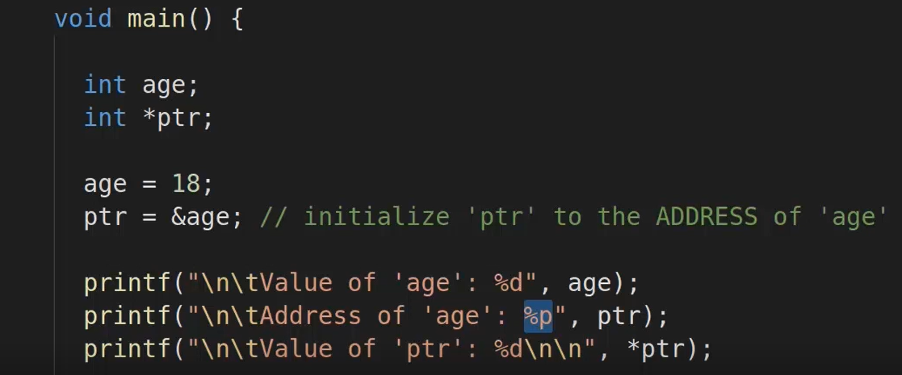

1. **Pointer with arrays**.

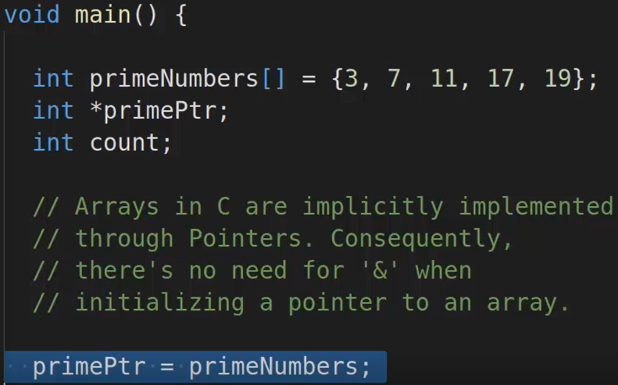

1. **Pointer with structures**.

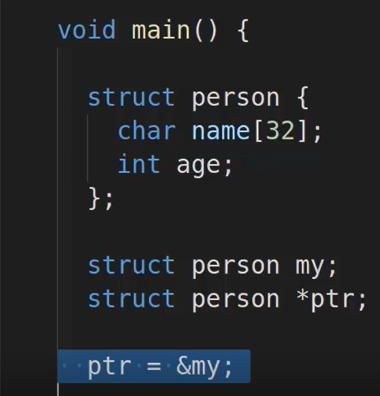

1. **Structure Padding**.

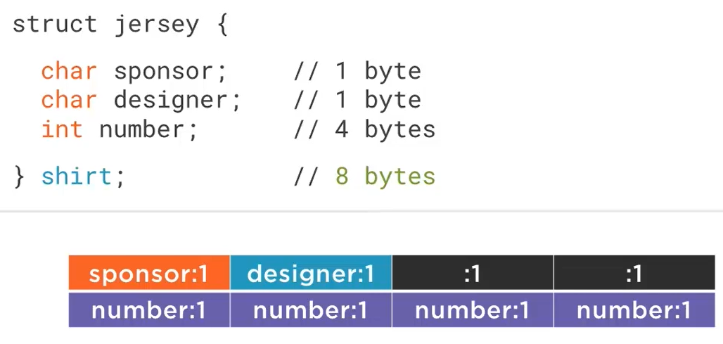

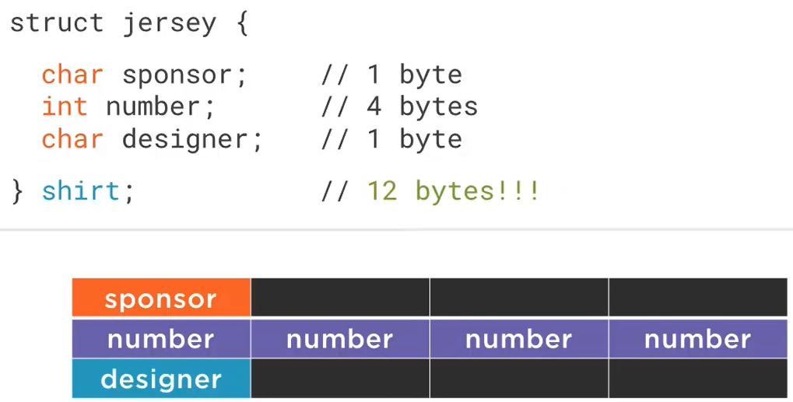

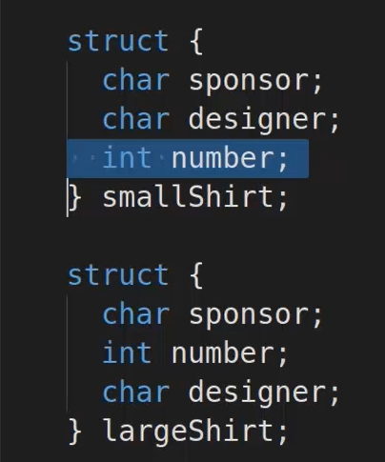

* A CPU takes one word at a time, depending on it is on 32 bit processor or 64 bit it will allocate 4 bytes or 8 bytes for a cycle.
* Structure “packing” saves us the memory that is being wasted due to padding
* We have to use the following directive

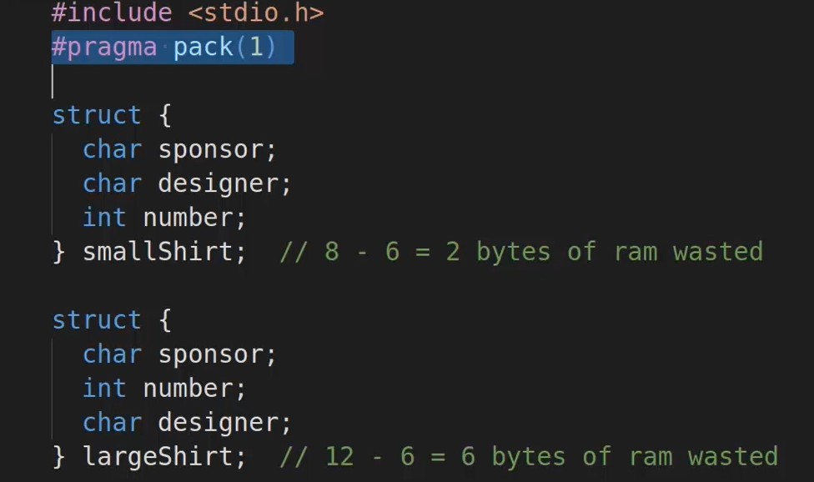

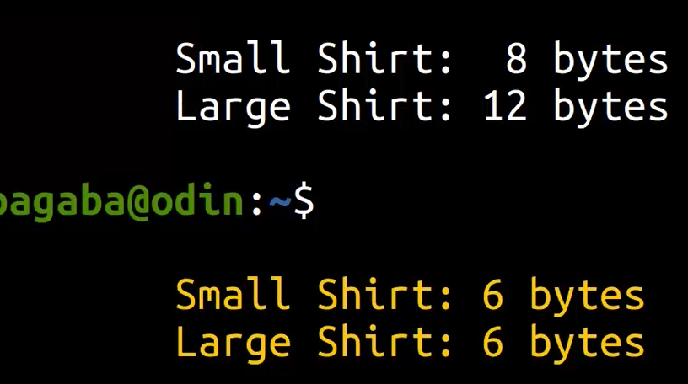

1. **Bit Fields**

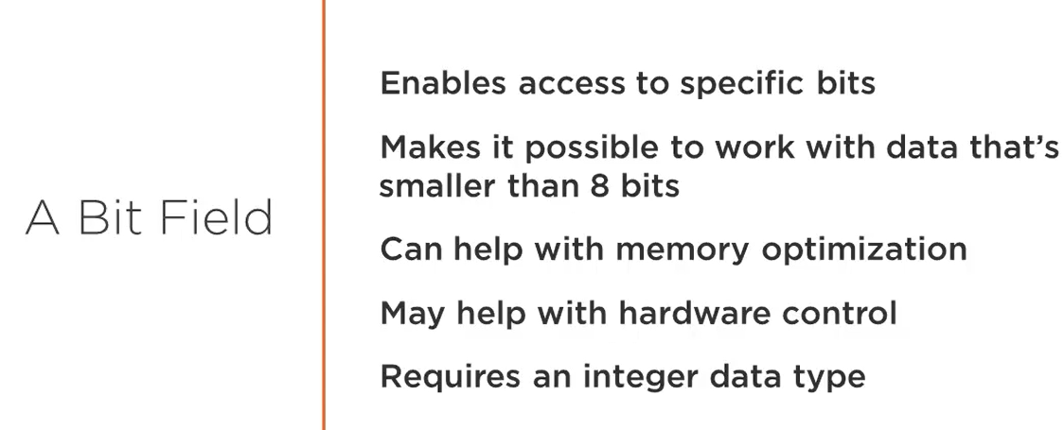

1. **How to manipulate bits**

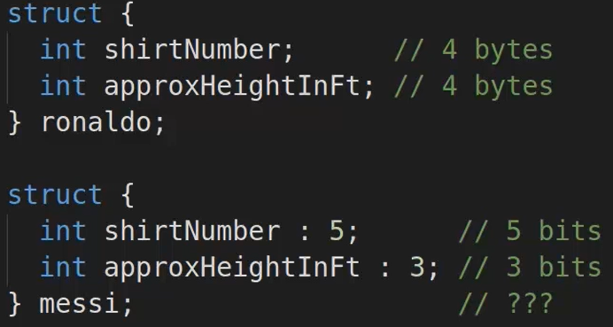

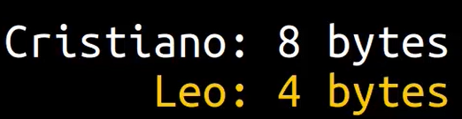

1. **Typedef** - The typedef is a keyword used to provide some meaningful names to the already existing variable in the program. It behaves similarly as we define the alias for the command.

Example – typedef unsigned int unit

1. **Union** – A union is a special data type available in C that allows to store different data types in the same memory location.

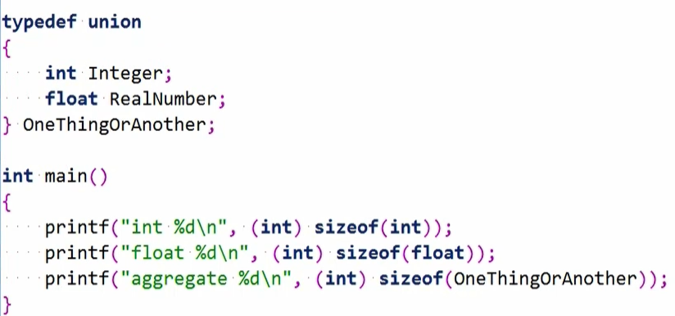

* The output will take the least amount of memory required to store any variable.
* Compiler or runtime have no idea what type is stored in a union.
* To give extra information we can use enumerations.
* And it will store the number starting from 0th index.

